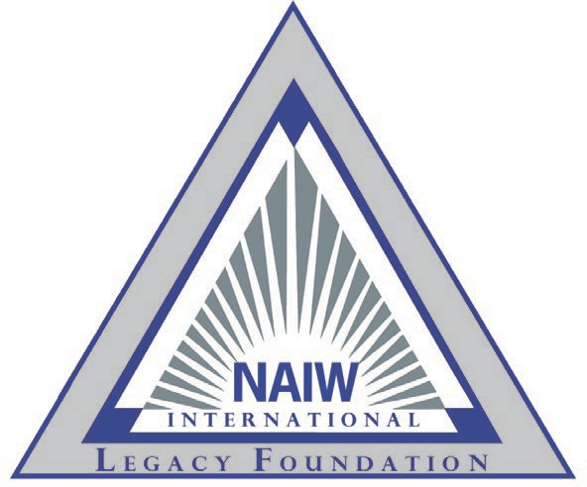

NAIW International Legacy Foundation

2024-2027 Strategic Plan At-A-Glance

Goal 1: **Raise Money**

* **Internal Donations:** Maintain donations from members at a target goal of **80%** of total donations.
* **External Donations:** Develop value proposition and solicitation campaign to reach corporate donors at a target goal of **15%** of total donations.
* **General Public:** Develop opportunities tosolicit additional donations from insurance affiliates at a target of **5%** of total donations.
* **Investment Strategy:** Maintain an investment strategy and policy to achieve growth of reserve funds.

# Goal 2: Fund the creation of educational programs as needs are identified

* **IAIP Needs Analysis:** Continue tocollaborate with IAIP to identify where on the association’s roadmap for future educational content the Foundation can support.
* **Industry Needs Analysis:** Consult with others in the industry to establish an educational roadmap.

# Goal 3: Provide opportunities for insurance professionals to receive education

* **Scholarships:** Continue to award scholarships supporting opportunities for IAIP members to enhance their insurance knowledge, obtain designations or insurance related degrees or to attend IAIP conventions or conferences. Look for ways to strength IAIP’s relationship with insurance related associations by offering IAIP educational bundle scholarships.
* **Grants:** Continue to award grants to local associations, councils and regions supporting education- related programs and projects benefiting the insurance industry and effectively educate IAIP members on a peer-to-peer basis.
* **Assess Scholarship & Grant Review Process:** Continue to Analyze if the review process with the current composition of the board is adequate.
* **Awarding Scholarships & Grants:** In preparation of increased donations via external sources, explore the opportunity to expand awarding grants/scholarships outside of IAIP membership.

# Goal 4: Board Structure and Leadership Composition

* **Board Structure:** Continue toanalyze the board structure and leadership composition to determine appropriate structure.
* **Management & Operations:** Continue toEvaluate management and operations needs to determine recommendation for future business operations structure. Review strategic plan annually at July, January and June board meetings.
* **Succession Planning:** In collaboration with the Legacy task Force, work to develop a list of potential Foundation chairs.